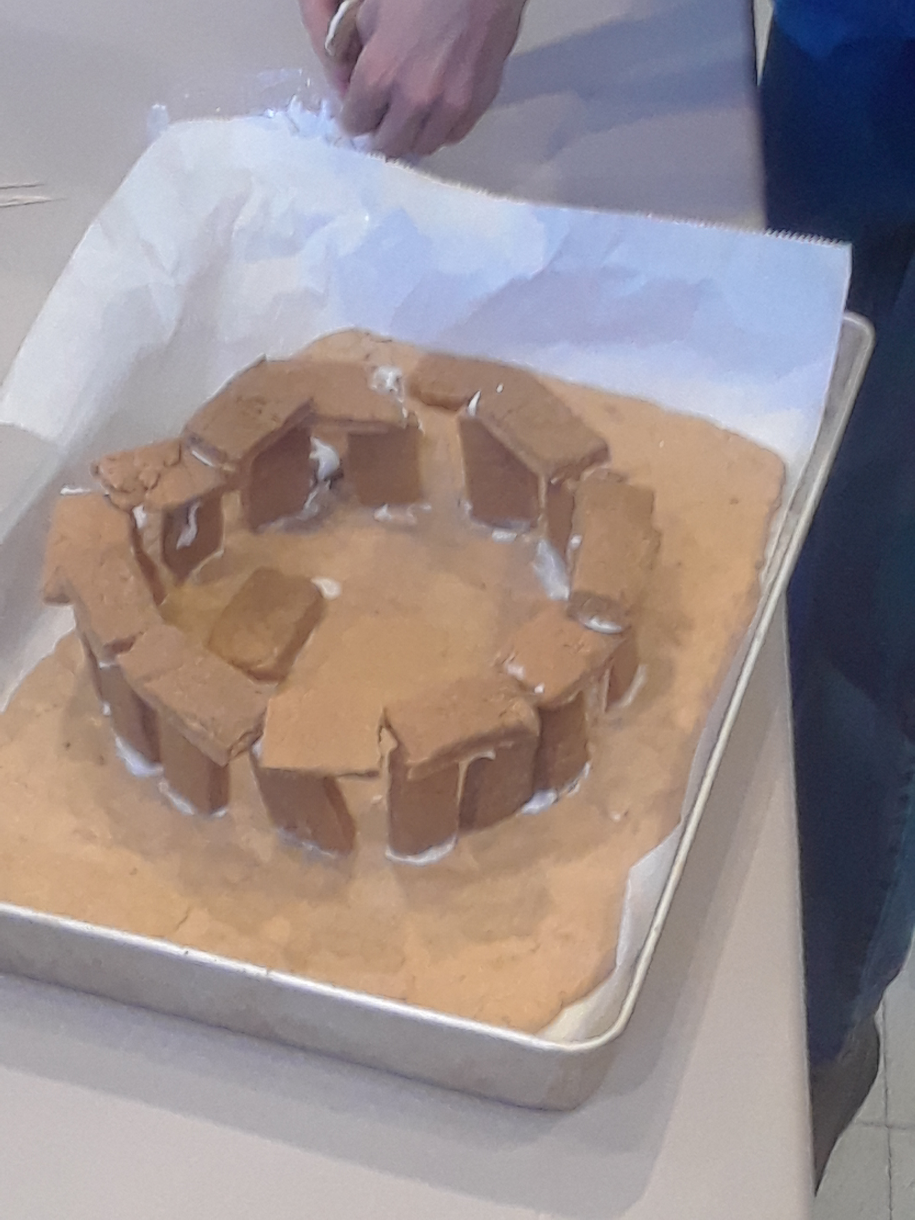  Who is UU Santa Fe?  Safe and Family-Friendly  We are Rev. Gail and Mr. Steven and a host of family-friendly volunteers working together with the awesome teachers and artists at Joy Montessori to create a safe, creative place for kids and parents (and grandparents) to explore big questions, build a warm community and practice living our values to create a healthier, more joyful world!  Rev. Gail is the mom of 17-year-old twins and the called minister/head magician at UU Santa Fe. Mr. Steven (dad of three) helps make kid-magic programming happen at UU Santa Fe.  Unitarian Universalism is a radically inclusive, life-affirming faith tradition. We live by the idea that justice is what love looks like in public and every one of us is called to Love the world… | Who is Joy Montessori?  Joy Montessori (ages 6-9) provides open-ended Montessori elementary curriculum based on a three-year-cycle. Rather than a yearly list of subject areas taught in a scheduled linear fashion pre-determined by a school board, all areas needed by the student will be covered sometime within a three-year time frame. “This allows your child to independently explore areas following their own interests while encouraging their lifelong love of learning."  Other Joy Montessori Programs  - Summer Camps – May through Aug  - Joy Academy - Self-Directed options for 11 - 15-year-old students  - Extended Care – For students that need before or aftercare 7:30 am to 5:30 pm weekdays  - Monthly Parent's Night Out  Find Us on the Web  - https://uusantafefaith.weebly.com/kid-camp-program.html  - https://www.joymontessori-nm.com/  kid camp Justice  107 W Barcelona Rd  Santa Fe, NM 87505 | 2 Come Journey With Us  kid camp Justice  - A Joint Venture between UU Santa Fe and  Joy Montessori
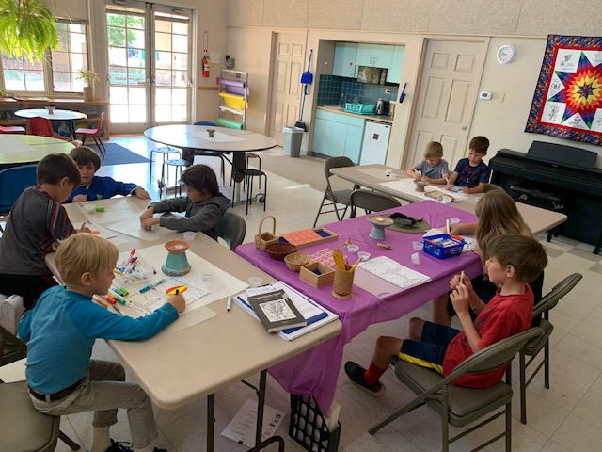  Who?  UU Santa Fe and Joy Montessori  Sponsored by UU Santa Fe and conducted by the Joy Montessori team, augmented by UU Santa Fe staff and volunteers from around Santa Fe.  What?  Justice  We will guide your child to develop an integration of body-mind-spirit, and integrity of self that will hold them through challenges and difficult times.  Our camps pursue a values-education, theme-based curriculum such as you might find in public schools, thus our camp is appropriate for all children, regardless of background or religious affiliation. | Our Next Camp?  - March 16-20, 2020  9 am – 3 pm daily  - Extended Care available at  extra cost - 7:30 am – 5:30 pm  Where?  - UU Santa Fe  - 107 West Barcelona Road  - 505.982.9674  - dre@uusantafe.org  - https://uusantafefaith.weebly.com/kid-camp-program.html  Why?  Because their school’s out but your work isn’t. And you need a safe affordable place where your kids can keep learning and growing. Our place will keep your kids safe and engaged while they have fun and help make the world a better place.  How Much?  - First child $275 (plus tax 8.44%)  - 2nd child 20% discount  - 3rd child 70% discount  - 4th child 80% discount  - Before and aftercare rate $10/hr. (7:30 am – 5:30 pm)  - Daily rate $60/day/child | 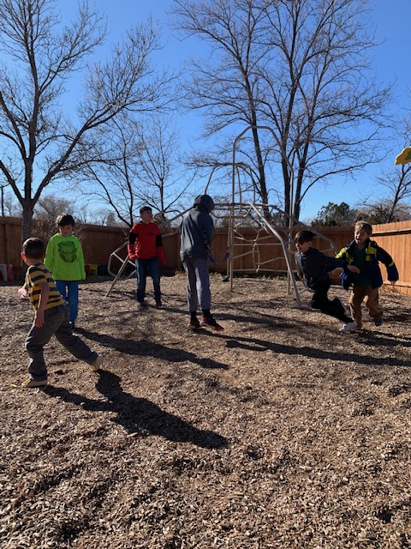  Four Week-Long Camps  Registration Open Now  https://uusantafefaith.weebly.com/kid-camp-program.html  - December 16-20, 2019  winter break - Holidays  - March 16-20, 2020  spring break - Justice  - May 26-29, 2020  summer break #1 - Nature  - August 3-7, 2020  summer break #2 – Peace  - [All staff, paid and volunteer, who have unsupervised access to children are background-checked.]

